**Autoimmune disorders linked to an increased risk of dementia**

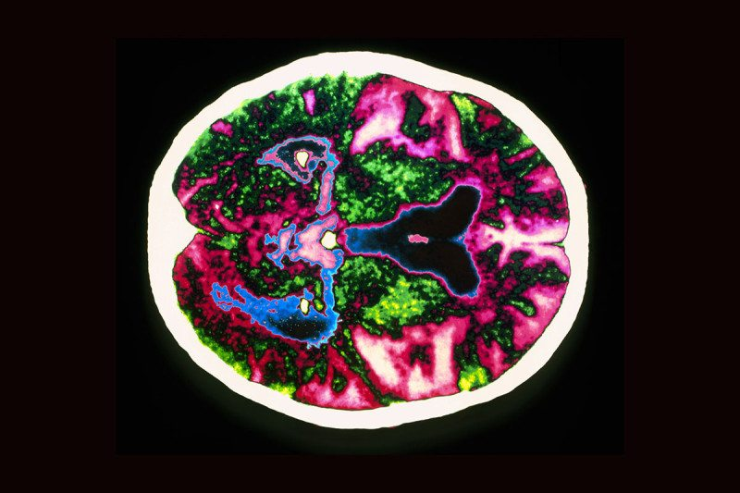

Alzheimer’s disease: is chronic inflammation to blame?

Zephyr/Science Photo Library

By **Andy Coghlan**

People who have autoimmune disorders may be 20 per cent more likely to develop dementia. That’s according to an analysis of 1.8 million hospital cases in England.

Based on data collected between 1999 and 2012, the study’s findings add to mounting evidence that chronic inflammation – a common feature of many autoimmune disorders – [may be a trigger of dementia and Alzheimer’s disease](https://www.newscientist.com/article/mg20327253.700-new-look-at-alzheimers-could-revolutionise-treatment/?DCMP=OTC-rss&nsref=online-news).

Previous studies have found that if infections or chronic inflammatory diseases – including diabetes – have pushed a person’s immune system into overdrive, this can lead to immune cells [attacking healthy brain tissue](https://www.newscientist.com/article/mg22229662-600-how-ailing-bodies-hasten-the-progress-of-alzheimers/).

**Varying effect**

According to the analysis, people with multiple sclerosis are among those with autoimmune disorders who are most likely to develop dementia. This finding isn’t very surprising, as the disorder is caused by the immune system attacking the central nervous system. The study, led by [Michael Goldacre](https://www.ndph.ox.ac.uk/team/michael-goldacre) at the University of Oxford, found that people with the condition have double the risk of developing dementia.

But other autoimmune disorders were also associated with rises in dementia risk. The skin condition psoriasis was linked to a 29 per cent increase, while the risk of developing dementia was 46 per cent higher in people who have lupus erythematosus, a disorder that involves rashes and fatigue.

However, people with [rheumatoid arthritis](https://www.newscientist.com/article/mg22329782-600-arthritis-drug-shows-potential-to-stall-alzheimers/) turned out to have around a 10 per cent lower risk of dementia. This could be because many people with arthritis take non-steroidal anti-inflammatory drugs, such as aspirin and ibuprofen, which may tame inflammation that could otherwise contribute to causing dementia.

“They reduce inflammation and that could explain why there’s less spillover, at least in principle,” says Goldacre.

**Heart and head**

His team also found a strong link between autoimmune disease and heart and circulatory problems. Overall, people with autoimmune disease were 53 per cent more likely to be admitted to hospital due to cardiovascular disease, and 46 per cent more likely to be admitted for a stroke.

This may explain a large part of the increased dementia risk in people with autoimmune disorders. Vascular dementia is a kind of dementia that involves poor blood flow in the brain. When Goldacre and his team looked specifically at different kinds of dementias, they found that people with autoimmune diseases are 29 per cent more likely to develop vascular dementia, but only 6 per cent more likely to get Alzheimer’s disease.

“It’s striking that increased risk for vascular dementia exceeds that for Alzheimer’s,” says [Colm Cunningham](http://www.tcd.ie/Biochemistry/research/c_cunningham.php) at Trinity College Dublin, Ireland. “The impact of autoimmune diseases on cardiovascular disease may be the key common link.”

Nevertheless, the relatively smaller increase in Alzheimer’s risk associated with autoimmune conditions may help researchers understand this disease better. “The results are very compelling and support the notion that neurovascular damage and inflammation are key drivers of risk for Alzheimer’s disease,” says leading Alzheimer’s researcher [Rudolph Tanzi](http://www.massgeneral.org/neurology/researcher_profiles/tanzi_rudolph.aspx), at Massachusetts General Hospital in Charlestown.

For those looking to reduce dementia risk by controlling their inflammation levels, Goldacre says exercise and a healthy diet may help. “These are good for avoiding Alzheimer’s, but for all sorts of other benefits too,” he says.

**Journal reference:***Journal of Epidemiology & Community Health***,**[DOI: 10.1136/jech-2016-207809](http://jech.bmj.com/)

**Read more:** [Mysterious dark brain cells linked to Alzheimer’s and stress](https://www.newscientist.com/article/2099465-mysterious-dark-brain-cells-linked-to-alzheimers-and-stress/)

**More on these topics:**

* [brains](https://www.newscientist.com/article-topic/brains/)
* [dementia](https://www.newscientist.com/article-topic/dementia/)
* [immune system](https://www.newscientist.com/article-topic/immune-system/)
* [medicine](https://www.newscientist.com/article-topic/medicine/)
* [mental health](https://www.newscientist.com/article-topic/mental-health/)